Functionality
Asset retirement is the removal of an asset or part of an asset from the asset portfolio. This removal of an asset (or part of an asset) is posted from a bookkeeping perspective as an asset retirement.

Scenario
SAP provides the following types of retirement:
An asset is sold, resulting in revenue being earned. The sale is posted with a customer. (Illustrated here)
An asset is sold, resulting in revenue being earned. The sale revenue is posted via a debit to a clearing account.
An asset has to be scrapped, with no revenue earned.
An asset is sold to an affiliated company (refer to Manual Posting of Inter company Asset Transfer/Retirement)

Requirements
Check the date specifications, and make any necessary entries on the Transaction data tab page. If you do not enter an asset value date, the system automatically determines this date when you save.

Menu Path | Accounting → Financial Accounting → Fixed Assets → Posting → Retirement → Retirement w/Revenue → F-92 - With Customer
Transaction Code | F-92

Updating the following field:
Step 1

Field Name | Field Description | Values
Document date | Date the transaction occurred | Example: 21.3.2012
Type | Code identifying the material type | Example: DR
Company code | Code identifying a separate legal entity for which a separate set of accounts is maintained for external reporting purposes | Example: ST1
Posting date | Date that the business transaction occurred | Example: 21.3.2012
Currency/rate | Code identifying the currency used in the transaction | Example: INR
Reference | The reference document number can contain the document number of the customer/vendor. However it may contain a different value. | Example: ref
Account | Code identifying the General Ledger, Vendor, or Customer account | Example:

Step 2

Field Name | Field Description | Values
Amount | Amount of the line item | Example: 20000
PstKy | Two-digit numeric key that determines the way line items are posted.This key determines several factors including the: Account type and Type of posting (debit or credit) | Example: 50
Account | Code identifying the General Ledger, Vendor, or Customer account | Example:
Trans.type | The transaction type in Asset Accounting classifies the business transaction. The transaction type controls various system activities when business transactions are posted. | Example: 210
Bline date | Enter the date the original document was created. | Example: 21.3.2012

Step 3

Field Name | Field Description | Values
Amount | Amount of the line item | Example: *

checkbox> Asst retirement .
Click the Enter button.

AJAB -

Functionality
You use the year-end closing program to close the fiscal year for one or more company codes from an accounting perspective. Once the fiscal year is closed, you can no longer post or change values within Asset Accounting (for example, by recalculating depreciation). The fiscal year in Asset Accounting that is closed is always the year following the last closed fiscal year in Asset Accounting. You can not close the current fiscal year until all depreciation values have been posted.

Scenario
All required steps before year-end closing have been completed including depreciation for all relevant periods (refer to Preparation for Year-end Closing )

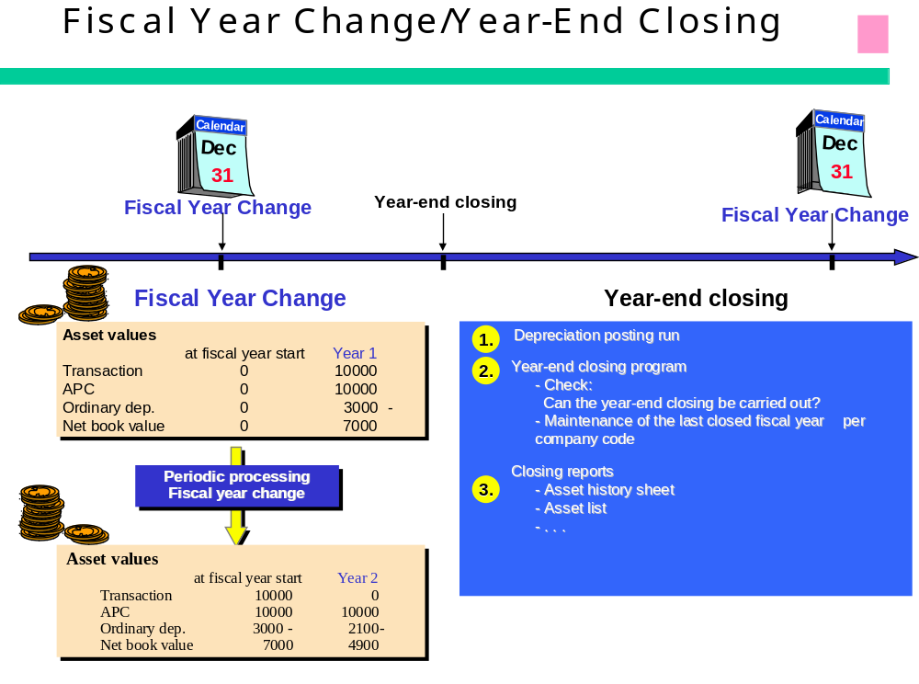

Requirements
You have run the report “ABST2” Account Reconciliation and reconciled the asset ledger with the general ledger. Depreciation should have been completely posted.

Menu Path | Accounting → Financial Accounting → Fixed Assets → Periodic Processing → Year-End Closing → AJAB - Execute
Transaction Code | AJAB

Double Click on AJAB - Execute

Update the following fields:

Field Name | Field Description | Values
Company code | The company code is an organizational unit within financial accounting. | Example: ST1
For fiscal year | Period, 12 months as a rule, for which the company is to create its inventory and balance sheet. | Example: 2011

Deactivate the Test Run button Test run .

Select ProgramExecute in background.
Click the Enter button to confirm your entries.

Click Immediate button.

Note: To run the job at a later time or after a specific event, select the relevant button. or .
Click the Save button.
Year-End Closing Asset Accounting

Select SystemServicesJobsJob overview.

Simple Job Selection

Click Execute Button.
Job Overview

Click RAJABS00 Button.
Click Spool Button.
Click 2027 Button.
Click Display button.
Graphical display of spool request 2027 in system DS1
The system displays a status message of the transaction.

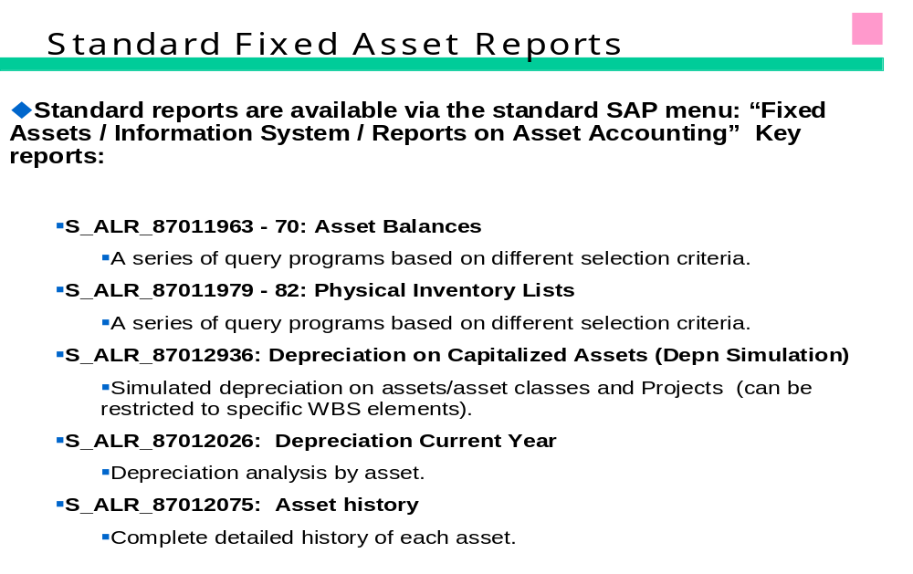
House Bank

Introduction

The component Bank accounting is use to handle accounting transaction that you process with your bank. It includes the management of Bank master data The creation & processing of incoming & outgoing payment. All country specific characteristics such as the specification of manual & electronic payment procedure, payment forms or data media can be freely define.

We will configure a house bank for our company code ST1. We will also cover the configuration manual electronic bank statement, cheque deposit & cash Journal.

- There are two main factors to be considered while managing bank accounts in SAP system:
  - House banks
  - Bank accounts

- For every company code we need to define its house bank. These are an equivalent of the “real” banks that the company operates with.

- For every house bank there are defined one (or more) bank accounts - these are simply our bank accounts per house bank.

- The bank account data contains the number of the account at the bank, the account currency and the G/L account which reflects the postings on your bank account in the general ledger.

- For each bank account, a G/L account must be created. This G/L account is assigned to the bank account and vice versa. Both accounts have to have the same account currency.

Bank Account ID:

Each bank ID is unique within a company code. For each bank, enter the bank country, & either the bank number or an appropriate country specific key. The system uses this information to identify the correct bank master data.

Bank Key:
In this field, you specify the bank key under which bank data from the respective country is stored.
When you define the country key, you also specify the country-specific definition of the bank key.
Normally, you manage banks using their bank number. The bank number in the control data for the bank is then displayed twice, that is, as the bank key too.
In certain countries, the bank account number takes on this function; then there are no bank numbers and the bank data is managed using the account number.
For data medium exchange, you may find it useful to be able to enter foreign business partners without a bank number, even if there are bank numbers in the country in question. In this case, the bank key can be assigned internally.
To manage bank data using another key, for example, the SWIFT code, external number assignment can also be used.

SWIFT Code for International Payments
Uniquely identifies a bank throughout the world.

Use
The S.W.I.F.T. code is used for identifying banks in international payment transactions.

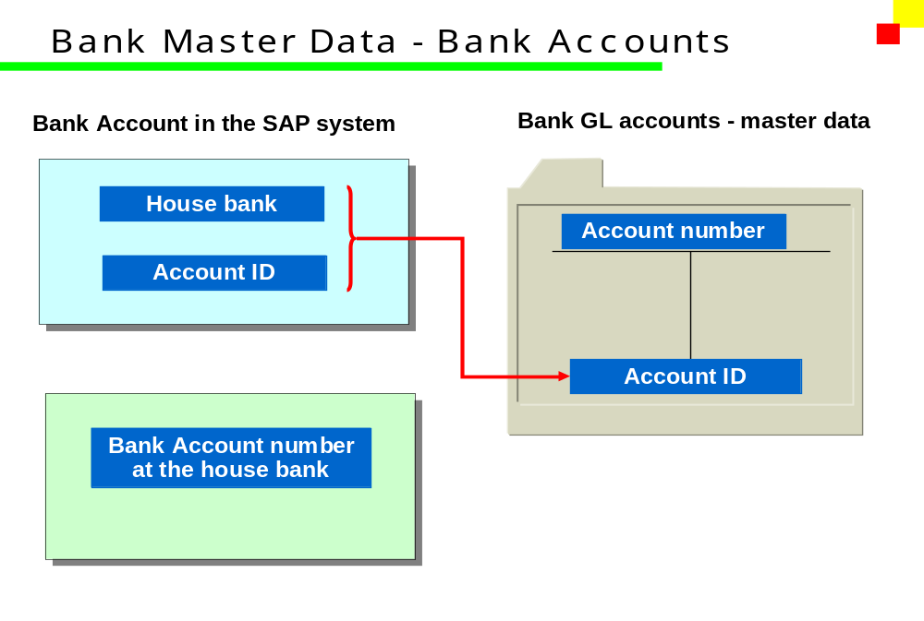

FI01 -

Functionality
Bank Master Records are stored in the bank directory. Their details are stored also in Customer / Vendor Master Data and are used by payment program to prepare payment documents. You can create new Bank Master Record using transaction FI01 or you during maintaining Cuts. / Vendor Master Data.

Scenario
You want to store in the system the details of a new bank.

Requirements

Menu Path | SPRO IMG – Financial accounting (new) – Bank Accounting - Bank Accounts – Define House bank.
Transaction Code | FI12

In company code ST1 (Spentext group of industries) we define the house bank as: SBI1

General ledgers Accounts for house bank SBI1 As follows:

A/C no. | G/L account | Under G/L Group | Account ID | Bank Key
103 | SBI Current account | Current Asset | 100 | 1000
302 | Cheque Issue Account | Current liability | 150 | 1001
104 | Cheque deposit Account | Current Asset | 180 | 1800

Configuration use for Above G/L accounts as bellow:

Field Description | Configuration
Balance In Local currency | Y
Posting without tax | Y
Open Item | Y
Line Item | Y
Sort Key | 001
Field Studious variant | G005
Relevant To cash flow | Y

Check Lots for the Company Code ST1:

Checks are divided into check lots which are separated (physically and logically). Checks which are supplied by a house bank or printer's are divided this way in different printer locations or they are in part for the automatic printing process, in part for a manual filling out. If different lots are to be used in a certain sequence, a subsequent lot is to be specified.

Indicator: Non-Sequential Check Number Management
Select this indicator if you do not want the check numbers to be used sequentially, but in an order decided externally.
Check lots which are marked as non-sequential cannot be used in automatic payment transactions or in online check printing. It is therefore only worthwhile to use these checks if the issuer writes the checks without using the SAP system (each lot in the order of his choice), and then defines the relevant information in the SAP system at a later date.
Checks from non-sequential check lots can only be archived once all the checks from that lot have been issued and are able to be archived.

For ST1 we define the following Cheque lots.

Lot No | From | To | Description | Date
01 | 000001 | 500000 | Pre printed Cheque lot 01For ST 1 | 2.2.2012
02 | 500001 | 750000 | Pre printed Cheque lot 02For ST 1 | 2.2.2012
03 | 750001 | 999999 | Pre printed Cheque lot 03For ST 1 | 2.2.2012
04 | 152876 | 188870 | Loose Cheque lot 01 For ST1 | 2.2.2012
05 | 433553 | 724122 | Loose Cheque lot 02 For ST1 | 2.2.2012
06 | 856566 | 927231 | Loose Cheque lot 03 For ST1 | 2.2.2012

A) Transaction Entry for Cheque received

1) SBI Current account……….Dr
To Customer A/C……….Cr

2) Cheque Deposit A/C……….Dr
To SBI Current A/C……..Cr.

So the Effect will be

Cheque Deposit A/C……..Dr.
To Customer A/C ………Cr.

B) Transaction Entry for Cheque paid.

- Vendor A/c ………..Dr
To SBI Current A/c…..Cr.

- SBI Current A/c………..Dr.
To Cheque Issue A/c…….Cr.

So the Effect will be

Vendor A/c ………….Dr.
To Cheque Issue A/c…….Cr.

Accounts Payable.

The Accounts Payable application component records and manages accounting data for all vendors. It is also an integral part of the purchasing system: Deliveries and invoices are managed according to vendors. The system automatically triggers postings in response to the operative transactions. In the same way, the system supplies the Cash Management application component with figures from invoices in order to optimize liquidity planning.

Payables are paid with the payment program. The payment program supports all standard Payment methods (such as checks and transfers) in printed form as well as in electronic form (data medium exchange on disk and electronic data interchange). This program also covers country-specific payment methods.

If necessary, dunning notices can be created for outstanding receivables (for example, to receive payment for a credit memo). The dunning program supports this function.

Postings made in Accounts Payable are simultaneously recorded in the General Ledger where different G/L accounts are updated based on the transaction involved (payables and down payments, for example). The system contains due date forecasts and other standard reports that you can use to help you monitor open items. You can design balance confirmations, account statements, and other forms of reports to suit your requirements in business correspondence with vendors. There are balance lists, journals, balance audit trails, and other internal evaluations available for documenting transactions in
Accounts Payable.

Vendor Master Data

Business transactions are posted to accounts and managed using those accounts. You must create a master record for each account that you require. The master record controls how business transactions are recorded and processed by the system.

Specifications you make in master records are used:

- As default values when you post items to the account. For example, the terms of payment you specify in the master record are defaulted for document entry.

- For processing business transactions For instance, bank details and the payment methods (check or bank transfer, for example) are required for automatic payments.

- For working with master records. You can prevent certain users from accessing an accountby setting up authorization groups.

In addition, line item display and open item management are defined automatically for each
vendor account.

This section explains the concept of vendor master data and describes how to create, display, change, block, and delete vendor master data.

A vendor master record contains:

- Vendor’s name, address, language, and phone numbers

- Tax numbers

- Bank details

- Account control data like the number of the G/L reconciliation account for the vendor account

- Payment methods and terms of payment set up with the vendor

- Purchasing data

Function of the Account Group.

Account groups determine:

- The type of number assignment,

- A number range for assigning account numbers,

- Which fields are displayed and whether their entry is optional or required (field status) when
- You enter or change vendor master data.

- Whether the account is for one-time vendors

To create a master record, you have to specify an account group. The account group cannot be
Changed after you create the master record. Your system administrator, however, can change
The above-mentioned account group specifications. For more information on account group
Specifications see the Define account group with screen layout activity in Customizing for Accounts Payable.
A change in the account group specifications may be necessary if you want to add fields to the master record that were previously hidden. For instance, if you implement Materials Management after implementing Financial Accounting, you will need to have additional fields displayed in the master record.

For the Company Code ST1 we define the following account group for accounts payable (vendor)

Sr.no. | Group | Description
01 | ST1F | Vendor For finance ST1
02 | ST1L | Vendor For Loan ST1
03 | ST1M | Vendor For Material ST1

Definition & assignment Number Range vendor account.

Each master record has a unique number. You need this number to display or change the master record and to post to the vendor account.

The vendor master record number can be assigned either internally or externally. Internal numbers are assigned by the system, whereas you enter external numbers yourself when you create the vendor master record. External numbers can be alphanumeric.

The account group determines whether account numbers are internal or external and what the valid number interval for a vendor master record is.
The system ensures that the numbers assigned are always unique. With internal assignment, the system selects the next number from the interval. With external assignment, the system prevents you from entering the same number twice. A vendor

In this activity you create the number ranges for vendor accounts. To do this, specify the following under a two-character key:
- A number interval from which the account number for the vendor accounts is to be selected
- The type of number assignment (internal or external number assignment)
Assign the number ranges to the account groups for vendors.
Following Number ranges are defined to the vender account for co code ST1

Group | Description | No Range | From | To
ST1F | Vendor For finance ST1 | 02 | 0000100000 | 0000199999
ST1L | Vendor For Loan ST1 | 03 | 0000200000 | 0000399999
ST1M | Vendor For Material ST1 | 06 | 6000000000 | 6999999999

XK01 -

Functionality
All Master Data in company may be managed centrally. The vendor master consists of financial and purchasing data. The financial data is used to register all accounting data necessary e.g. to be able to pay the vendor for its delivered services. The finance department will maintain this data. The creation of the new vendor master consists of two phases:
- The purchasing department (supplier administrator) will create the necessary purchasing data and block the vendor for purchasing. After the qualification process the vendor is (if approved) unblocked,
- Then the finance department is informed about the new vendor master and a responsible person will enter the financial data in the vendor master (e.g. reconciliation GL account). This phase is done per company code.

Scenario
Purchasing Department informed you that a new vendor master was approved and unblocked. You need to enter now additional data.

Requirements
Created and approved vendor purchasing master data.

Menu Path | Accounting → Financial Accounting → Accounts Payable → Master records → Maintain centrally → XK01 - Create
Transaction Code | XK01

Double click on XK01 – Create
We create the Venders account from this screen for the company spentex group of industries (ST1)

Functions of the Reconciliation Account: Vendor Master
Records
When you post items to a subsidiary ledger, the system automatically posts the same data to the
General ledger (see the following illustration). Each subsidiary ledger has one or more Reconciliation accounts in the general ledger. These reconciliation accounts ensure that the Balance of G/L accounts is always zero. This means that you can draw up balance sheets at any time without having to transfer totals from the sub ledgers to the general ledger.

You have to specify a reconciliation account in every vendor master record. Settings made in a Reconciliation account also affect the vendor accounts:

- You can use the reconciliation account to configure the screens for posting items to vendor accounts. Using the reconciliation account you could, for example, hide the fields for exchange rate hedges if these types of transaction are not made. For more information, seethe documentation on Document Posting.

- You can also use the reconciliation account to specify which currencies you can post to the corresponding vendor accounts.

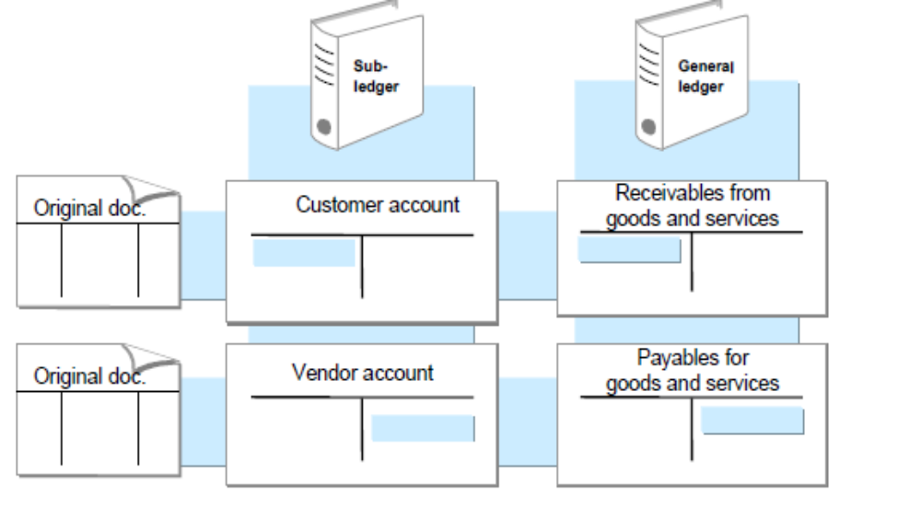

Posting Business Transactions in Accounts Receivable

Vender invoice-

Transaction Code: FB60

You can use this function to enter incoming or outgoing invoices or credit memos. The invoice/credit memo entry Enjoy transaction is a single screen transaction. This means that you can enter, hold, park, and post documents on one screen with a minimum amount of entries.
The single screen transactions are included in the area menus for Accounts Payable according to the business transaction.

Integration

You can use the invoice entry single screen transaction in addition to the standard
Transactions. To access the standard transactions, from the SAP Easy Access screen, choose
Accounting _ financial accounting _ Accounts payable _ Document entry
_ Others _ Invoice - general

For complex postings, such as an asset purchase from a vendor, you can spring directly to the
Standard transaction. To do this, choose Environment _ Complex posting. The data that you
Have entered is transferred.
If you change back to the single screen transaction from the complex posting
Transaction, the data that you have already entered is lost.

Credit Memo Entry -

Procedure

From the SAP Easy Access screen, choose Accounting _ Financial accounting _ Accounts payable _ Document entry _ Invoice/Credit memo.

Transaction Code FB60

The first time you carry out this transaction, a dialog box appears prompting you to enter a company code. Enter the company code required for your invoices or credit memos. For all future document entry transactions, the system defaults this company code automatically.

You have to make the following entries on the Basic data tab:

Customer/vendor account number

- Invoice date

- Posting date

- Invoice amount

All of the other specifications on this tab are optional entries:

Vendor Credit Memo, Debit Memo from FI side and JV

Credit Memo/ Debit Memo will usually flow from MM Module only for price differences/ goods returns etc., In case a credit /debit memo has to be posted from FI, following documentation may be followed.

Vendor Credit Memo (In fact a Debit Memo)

In the SAP system there is no concept of Debit Memo available for either Vendor or Customer. Vendor Credit Memo works in SAP as a debit memo as the same will debit the vendor a/c. So, to debit a Vendor, use Credit Memo.

Special G/L Indicators (Accounts Payable)

To enter a special G/L transaction, you must enter a special G/L indicator in the line item. The system then posts the line item to a reconciliation account other than the one in the vendor master record. These special G/L accounts are reported separately in the balance sheet. The most frequent special G/L transactions are:

- Down payments

- Bills of exchange

- Guarantees

- Security deposits

- Individual value adjustments

- Amortization

- Interest payable

You can post down payments and bills of exchange using special functions.

Define Alternative Reconciliation Account for Down Payments
In this step, you define an account in which the vendor down payments are managed in the general ledger. The down payment posting is then automatically made to this account instead of to the normal payables account (reconciliation account).
You can group the specifications account type, special G/L indicator and reconciliation account together under one three-character key. You store the clearing accounts for input tax under this key in the next step. This is only necessary if you display down payments gross.
You specify in the alternative reconciliation account via the Tax category field whether a down payment is displayed gross or net.
Activities
1. Specify the number of the alternative reconciliation account.

2. Make sure that the account is created and that the Tax category field is filled correctly.

3. If you want the gross display, specify the clearing accounts for input tax in the next step.

